Welcome!
Date
Name
Spouse
Address
City
State Zip _________
Email

Please Contact By
❑ Card  Phone  Visit

Telephone Best Time to Call
Home ______________
Work ______________

Guest: First Time Second Time
Are you a church member: yes no
Church
City, State

Circle Appropriate Age/Grade Group(s)
Preschool: Ages: B-1 2-3 4-5
Children: Grades: K 1 2 3 4 5 6
Youth: Grades: 7 8 9 10 11 12
Adults: Ages:18-29 30s 40s 50s 60s+

How did you learn about our church?
Newspaper Friend Yellow Pages Mail
Other

I am a guest of:

New in the Community? Yes No
Names & ages of children at home

Weekly Service & Activity Schedule

Oct 30, 2016

9:45 a.m. Sunday School
11:00 a.m. Worship Service
6:00 p.m. Evening Service

Week of Oct 30, 2016

Wednesday 6:30 pm……………………Meal/Bible Study

Upcoming Events
November
6……………..Turn Clocks Back/New Commandment Kids
10……………………………………………..Adult Fellowship
12………………………………………………….Harvest Stew
13……………....…New Commandment Kids/Bus. Meeting
13-15………………....Texas Baptist Annual Meeting/Waco
24…………………………………………………Thanksgiving
New Commandment Kids

Ages Kinder thru 12th grade are welcome!
Hands-on mission work thru puppet ministry and crafts to share with nursing homes, shut-ins, etc.
Meeting the 1st and 2nd Sunday of each month @ 9:30 am


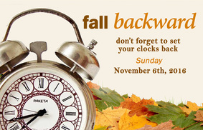

Don’t forget Harvest Stew
Saturday, Nov 12.
Good food, kid friendly games, gospel music and much more! Hope you can be there!!

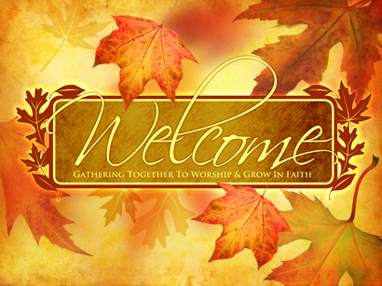

Knobbs Springs Baptist Church

October 30, 2016

Church Information:

KnobbsSpringsBC.com KnobbsSpringsBaptist@gmail.com

1662 CR 305, McDade, Texas 78650 512-273-2743

David Atwood, Pastor Cell 512-470-5098

Patti Radford, Office Manager Cell 512-968-7821

